Nepal College of Information Technology
Assessment-2009
Program: BE (ELX) Time: 3 hrs
Semester: Spring (IV) FM: 100
Subject: Numerical Method PM: 50

1. a) Solve
Cos3x=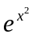-1 by
Secant method correct to three decimal place. 8
b) Solve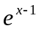-5x=0 by Newton-Raphson's method correct to four decimal place. 7

2. a) Find a real root of the equation
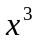+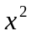-1=0 by iteration method correct to four decimal place. 7
b) The following data gives the melting point of an alloy of lead and zinc, where 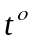c is the temperature and P is the percentage of lead in the alloy 8
P | 40 | 50 | 60 | 70 | 80 | 90
t | 184 | 204 | 226 | 250 | 276 | 304
Find meting point of alloy when p=45%

3. a) Fit a curve of model 8
y=a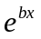 to the following data

x | 77 | 100 | 185 | 239
y | 2.4 | 3.4 | 7.0 | 11.0

b) Fit a second degree polynomial to the following data
x | 1 | 2 | 3 | 4
y | 6 | 11 | 18 | 27
by using least square method. 7

4. a) Using Gauss elimination method solve 8
10x-7y+3z+5u=6
-6x+8y-z-4u=5
3x+y+4z+11u=2
5x-9y-2z+4u=7 7
b) Find the factorization of the matrix
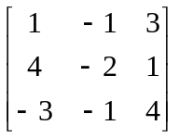

5. a) Find the largest eigen value and corresponding eigen vector of the matrix 7
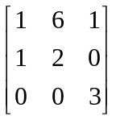
b) Solve 8
83x+11y-4z=95
7x+52y+13z=104
3x+8y+29z=71
By Gauss-seidal method

6. a) Solve =x+y+xy, y(0)=1 7
20
10

30  4₁ | 4₂ | 80
40 | 4₄ | 70
4₃

by Taylor's series method.
b) Solve the differential equation 8
=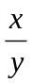 ,y(0)=1 by Euler's method taking h=0.5

7 Write short notes on(Any Two) 5x2
a) Errors in numerical computing
b) Interpolation and extrapolation
c) Ill-condition system.

